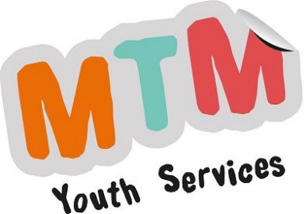

MTM Youth Services CIC

Service User Concerns and Complaints Policy

MTM Youth Services is committed to providing a high level service to you, our service users.

If you do not receive satisfaction from us we need you to tell us about it. This will help us to improve our standards.

If you have a concern or a complaint, please talk to your Youth Worker first of all and hopefully they'll be able to take action to resolve the problem or take action to ensure that it never happens again.

If your complaint is more serious then please write to one of the Directors of MTM Youth Services. Alternatively your complaint can be emailed. If your complaint is urgent then please telephone us and ask for your complaint to be looked at. Contact details are set out at the bottom of this document.

If you write to us, or email us, with a complaint, we will send you a letter or email acknowledging your complaint and ask you to confirm or explain the details set out if necessary. We will also let you know the name of the person who will be dealing with your complaint. You can expect to receive our letter within 5 - 7 days of us receiving your complaint.

- We will record your complaint within a day of having received it

- We will acknowledge your reply to our acknowledgment letter and confirm what will happen next. You can expect to receive our acknowledgment letter within 5 - 7 days of your reply.

We will then start to investigate your complaint by talking to the member of our team who is best placed to supply information or to respond. We will examine the member of team’s reply and the information you have provided for us. If necessary we may ask you to speak to them. This will take up to 7 days from receiving their reply. An MTM Youth Services Director will then invite you to meet him/her to discuss and hopefully resolve your complaint. S/he will do this within 5 days of the end of our investigation. Within 2 days of the meeting the Director will write to you to confirm what took place and any solutions s/he has agreed with you. If you do not want a meeting or it is not possible, the Director will send you a detailed reply to your complaint. This will include their suggestions for resolving the matter. They will do this within 5 days of completing their investigation.

At all times we will:

- Treat you with tact, courtesy and fairness
- Not treat you any differently because you have complained
- Not discriminate against you because of your colour, race, religion, age, sex or sexual orientation or because of any disability
- Acknowledge receipt of your complaint and tell you who is dealing with it or if it has been passed to another office
- Aim to respond within 10 working days and, if we can’t, tell you why and let you know when we will reply in full

Sam Mason 07778 896 325 sam@mtmyouthservices.org.uk
Harry Town 07715 336 885 harry@mtmyouthservices.org.uk

MTM Youth Services CIC
1 Rambler Cottage
The Street
BOTESDALE
Diss
IP22 1BZ
Reviewed by the Directors 21st July 2023

